<?= Html::submitButton($model->isNewRecord ? 'Create' : 'Update', [

'class' => $model->isNewRecord ? 'btn btn-success' : 'btn btn-primary', 'name' => 'submit-button',

]) ?>

</div>

<?php ActiveForm::end(); ?>

</div>

6. Now check that the controller works:

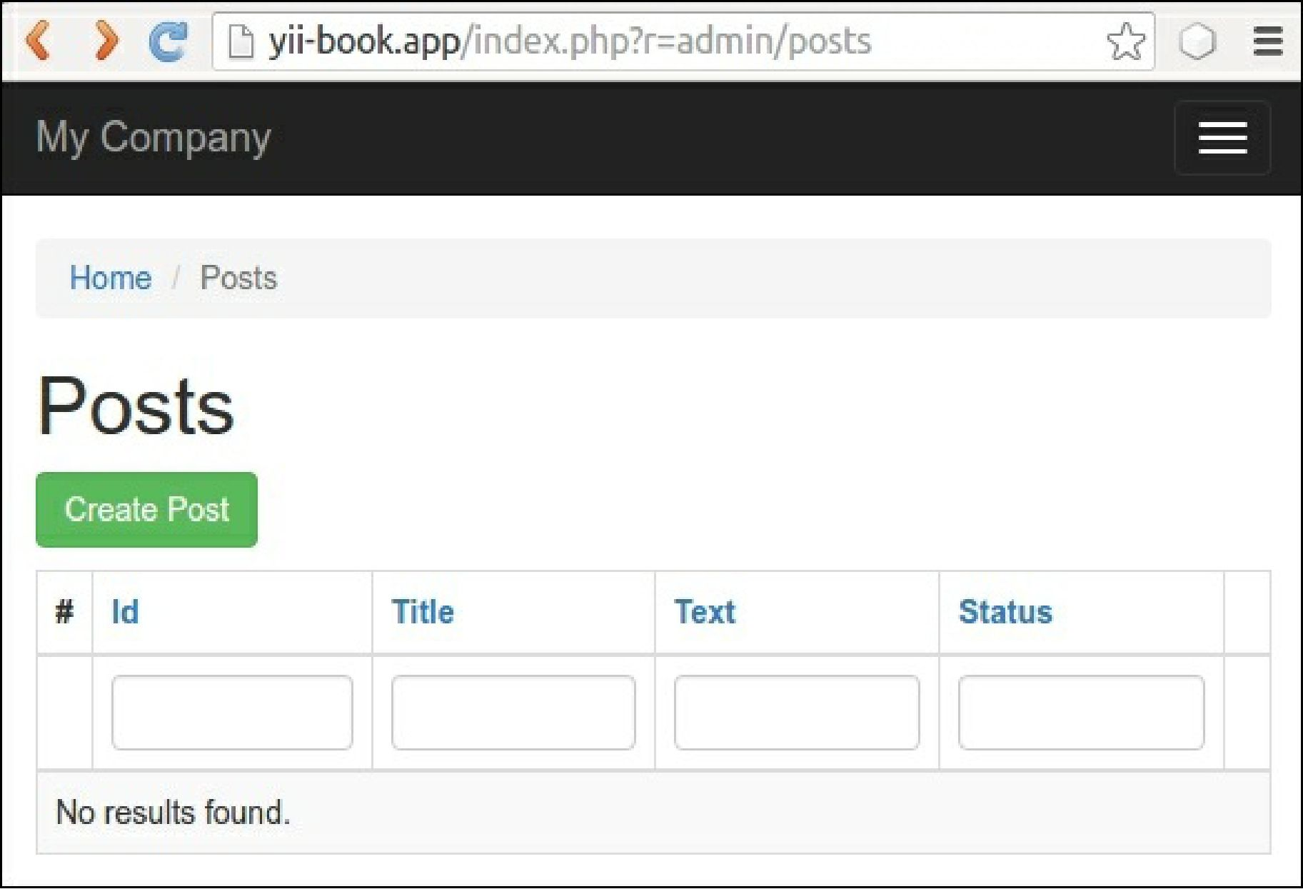

Create any demo posts.

How to do it...

**Preparing for the tests**

Follow these steps to prepare for the tests:

1. Create yii2_basic_tests or other test database and update it by applying migrations:

tests/bin/yii migrate